LegitBytes – SOD/EOD Automation System Documentation
Project Owner: Navyansh Nanda
Organization: LegitBytes
Document Type: Master Technical & User Documentation
Version: 1.0
Last Updated: May 2026

Table of Contents
- Executive Summary
- System Overview
- Overall Architecture
- Technologies Used
- Planner Bucket Structure
- SharePoint Data Structure
- Power Automate Flows
  - SOD Snapshot Flow
  - EOD Snapshot Flow
  - Blocked Tasks Snapshot Flow
  - Past EOD/Blocked Cleanup Flow
- n8n Summary Flow
- Azure App Registration & Microsoft Graph API Configuration
- Teams Summary Message Structure
- User Participation Guidelines
- Developer Notes & Maintenance Guide
- Team Label Configuration Logic
- Important Operational Rules
- Troubleshooting Guide
- Future Improvements
- Appendix

1. Executive Summary
This document explains the complete SOD/EOD task tracking and reporting automation system developed for LegitBytes.
The solution automates the collection, storage, processing, and reporting of:
- Start of Day (SOD) tasks
- End of Day (EOD) tasks
- Blocked/Delayed tasks
The system integrates:
- Microsoft Teams Planner
- Power Automate
- SharePoint
- n8n
- Microsoft Graph API
- Microsoft Teams Channels
The purpose of the system is to:
- Standardize employee daily reporting
- Improve team visibility
- Maintain historical task tracking
- Automate summary reporting
- Reduce manual follow-ups
- Provide structured operational reporting

2. System Overview
The automation system captures employee tasks from Microsoft Planner buckets at scheduled times, stores them in SharePoint, processes them using n8n, and posts formatted summaries into Microsoft Teams.

High-Level Workflow
Teams Planner → Power Automate → SharePoint → n8n → Teams Channel

Flow Explanation
- Employees manage tasks inside Microsoft Teams Planner.
- Power Automate flows extract task information at scheduled times.
- Extracted task data is stored in a SharePoint list.
- n8n reads SharePoint data daily.
- n8n generates structured HTML summaries.
- The summary is automatically posted to a Teams channel.

3. Overall Architecture

System Architecture Diagram
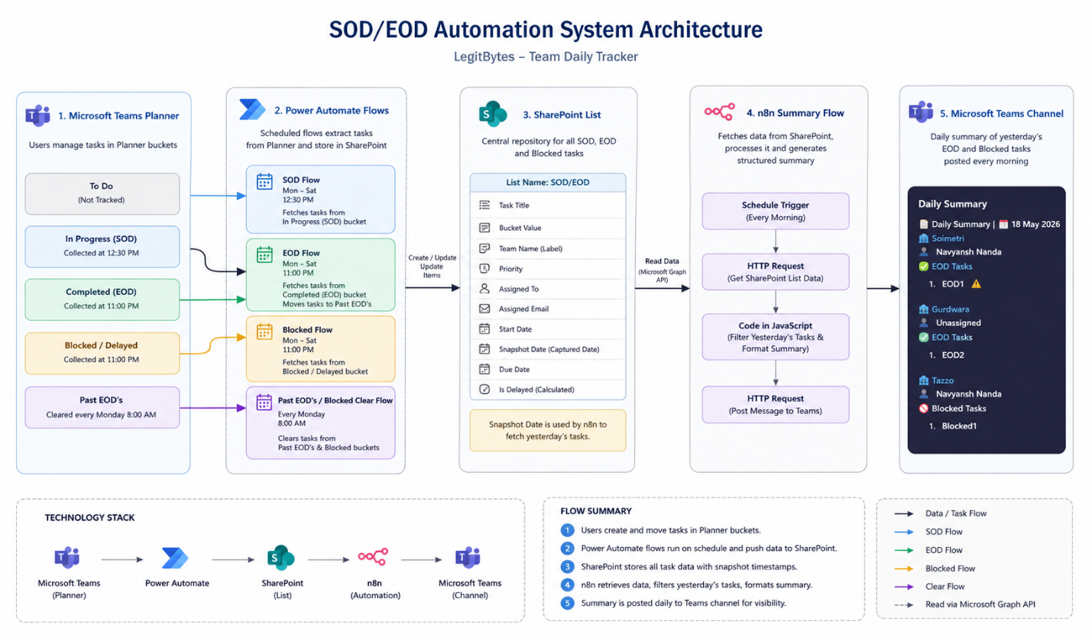

4. Technologies Used
Technology | Purpose
Microsoft Teams Planner | Task management interface for users
Power Automate | Task extraction and SharePoint storage
SharePoint Lists | Central structured task storage
n8n | Data processing and summary generation
Microsoft Graph API | Accessing SharePoint and Teams data
Azure App Registration | API authentication and permissions
Microsoft Teams Channel | Daily summary posting

5. Planner Bucket Structure
The Planner board contains multiple buckets used for different operational purposes.

Bucket Definitions

1. To Do
Purpose:
- General task planning bucket
- Not tracked by automation
- Users may freely add/remove tasks
Notes:
- Tasks in this bucket are ignored by all flows
- Used only for personal/team planning

2. In Progress (SOD)
Purpose:
- Contains tasks employees plan to work on during the day
Automation:
- Captured by the SOD Snapshot Flow
- Snapshot time: 12:30 PM
- Runs Monday to Saturday
Notes:
- Tasks may remain here for multiple days
- Long-running tasks are fully supported

3. Complete (EOD)
Purpose:
- Contains tasks completed during the day
Automation:
- Captured by the EOD Snapshot Flow
- Snapshot time: 11:00 PM
- Runs Monday to Saturday
Additional Behavior:
- After being stored in SharePoint, tasks are automatically moved to the “Past EOD’s” bucket

4. Blocked/Delayed
Purpose:
- Contains tasks blocked by dependencies, issues, or delays
Automation:
- Captured by the Blocked Snapshot Flow
- Snapshot time: 11:00 PM
- Runs Monday to Saturday
Notes:
- Users manually place blocked tasks into this bucket
- Tasks appear in daily Teams summaries

5. Past EOD’s
Purpose:
- Historical storage bucket for completed EOD tasks
Automation:
- Tasks are automatically moved here after EOD snapshot processing
- Cleared weekly every Monday at 8:00 AM
Notes:
- This bucket is used only for archival purposes
- Users generally do not interact with this bucket

6. SharePoint Data Structure

SharePoint List Name
SOD/EOD

Purpose
Acts as the centralized storage layer for all captured SOD, EOD, and Blocked task data.

SharePoint Columns
Column Name | Purpose
Task Title | Stores Planner task title
Bucket Value | Indicates SOD/EOD/BLOCKED
Team Name | Stores team label
Priority | Stores Planner priority
Assigned To | Stores assigned user names
Assigned Email | Stores assigned user emails
Start Date | Task start date
Snapshot Date | Date task was captured into SharePoint
Due Date | Task due date
Is Delayed | Indicates whether task is delayed

Calculated Column Logic

Is Delayed
The “Is Delayed” column is a calculated SharePoint column.
It compares:
- Snapshot Date
- Due Date
If the Snapshot Date exceeds the Due Date, the task is marked as delayed.
Example values:
- Yes - Delayed
- No - On Track

7. Power Automate Flows
The automation system contains four Power Automate flows.

7.1 SOD Snapshot Flow

Purpose
Captures all tasks from the “In Progress (SOD)” bucket and stores them into SharePoint.

Schedule
Property | Value
Frequency | Daily
Days | Monday to Saturday
Time | 12:30 PM

Flow Logic
- Trigger starts on schedule
- Planner buckets are fetched
- Planner tasks are fetched
- Tasks are iterated using “Apply to each”
- Bucket ID is checked using a condition block
- Matching SOD tasks are processed
- User details are extracted
- SharePoint item is created

Important Logic
The flow compares Planner Bucket IDs internally.
Only tasks belonging to the “In Progress (SOD)” bucket are processed.

7.2 EOD Snapshot Flow

Purpose
Captures completed tasks from the “Complete (EOD)” bucket.

Schedule
Property | Value
Frequency | Daily
Days | Monday to Saturday
Time | 11:00 PM

Flow Logic
- Trigger starts on schedule
- Planner tasks are fetched
- EOD bucket tasks are identified
- Task details are stored in SharePoint
- Tasks are moved to “Past EOD’s” bucket

7.3 Blocked Snapshot Flow

Purpose
Captures all blocked or delayed tasks.

Schedule
Property | Value
Frequency | Daily
Days | Monday to Saturday
Time | 11:00 PM

Flow Logic
- Trigger starts on schedule
- Planner tasks are fetched
- Blocked bucket tasks are identified
- Task details are stored in SharePoint

7.4 Past EOD/Blocked Cleanup Flow

Purpose
Clears historical buckets weekly.

Schedule
Property | Value
Frequency | Weekly
Day | Monday
Time | 8:00 AM

Flow Logic
- Trigger starts weekly
- Tasks from Past EOD/Blocked buckets are fetched
- Tasks are deleted automatically

8. n8n Summary Flow

Purpose
The n8n flow generates structured daily summaries using SharePoint data and posts them into a Microsoft Teams channel.

High-Level Logic
Scheduled Trigger → HTTP Request → JavaScript Processing → Teams Message Posting

Detailed Flow Steps

1. Scheduled Trigger
Starts automatically every morning.

2. HTTP Request
Fetches SharePoint list data using Microsoft Graph API.

3. JavaScript Processing
The JavaScript node:
- Processes SharePoint data
- Filters only previous day’s tasks
- Groups tasks by:
  - Team
  - Employee
  - Task Type
- Formats HTML output

Monday Special Handling
On Mondays:
- Friday tasks are included
- Saturday tasks are included
This is necessary because there are no Sunday operations.

4. Teams Message Posting
The formatted HTML summary is posted to a Microsoft Teams channel.

9. Azure App Registration & Microsoft Graph API Configuration

Purpose
Azure App Registration was required to:
- Authenticate n8n against Microsoft services
- Access SharePoint data
- Post Teams messages
- Use Microsoft Graph API securely

App Registration Name
n8n-legitbytes-summary-flow

Authentication Configuration

Redirect URI
Configured Redirect URI:
https://n8n.tazzo.ai/rest/oauth2-credential/callback

API Permissions
The following Microsoft Graph permissions were configured.
Permission | Type | Purpose
Channel.ReadBasic.All | Delegated | Read channel information
ChannelMessage.Read.All | Delegated | Read Teams messages
ChannelMessage.Send | Delegated | Send Teams messages
Chat.Read.All | Application | Read chats
Chat.ReadWrite | Delegated | Read/write chats
Sites.Read.All | Delegated | Read SharePoint data
Sites.ReadWrite.All | Delegated | Modify SharePoint data
Team.ReadBasic.All | Delegated | Read Teams information
User.Read | Delegated | Read user profile
Note:
Some permissions were added during development and testing but are not actively used in the final implementation.

10. Teams Summary Message Structure

Purpose
Provides employees and management with a structured daily summary of:
- EOD tasks
- Blocked tasks

Message Format
The summary message is generated in HTML.

Summary Structure
- Date Header
- Team Section
- Employee Section
- EOD Task Section
- Blocked Task Section
- Delay Indicators

11. User Participation Guidelines
This section explains how employees should use the system.

11.1 Mandatory User Requirements
Users MUST:
- Assign themselves to every task (SOD/EOD)
- Add the correct team label to every task
Failure to follow these requirements impacts reporting accuracy.

11.2 Recommended User Requirements
Users are strongly encouraged to:
- Add Start Dates
- Add Due Dates
This improves:
- Delay tracking
- Historical reporting
- Planning visibility

11.3 Daily Workflow for Employees

Morning Workflow (SOD)
Before 12:30 PM:
- Add planned tasks into the “In Progress (SOD)” bucket
- Ensure task is assigned to a user.
- Ensure correct team label is added

Evening Workflow (EOD)
Before 11:00 PM:
- Move completed tasks into “Complete (EOD)” bucket
- Ensure completed work is updated correctly

Blocked Tasks Workflow
If a task becomes blocked:
- Move task into “Blocked/Delayed” bucket
- Add notes describing the issue if necessary
Blocked tasks are included in the next day’s summary.

11.4 Drag-and-Drop Workflow
Users may:
- Create tasks in SOD bucket
- Drag tasks to EOD bucket when completed
- Drag tasks to Blocked bucket if delayed
This workflow minimizes duplicate task creation.

11.5 Notes & Checklists
Users may freely use:
- Task notes
- Task descriptions
- Task checklists
These are NOT captured into SharePoint.

12. Developer Notes & Maintenance Guide
This section contains technical implementation details for future developers.

12.1 Team Label Mapping Logic

Problem Statement
Planner labels internally remain:
- category1
- category2
- category3
Even after renaming them in the Teams UI.
Example:
Planner UI Label | Internal Backend Value
Tazzo | category1
Soimetri | category2
Gurdwara | category3
Because of this limitation, labels cannot be directly stored using their visible names.

Solution Implemented
Custom Power Automate expressions were added inside the “Create Item” block.

Team Name Expression
if(equals(items('Apply_to_each')?['appliedCategories']?['category1'], true), 'Tazzo', if(equals(items('Apply_to_each')?['appliedCategories']?['category2'], true), 'Soimetri', if(equals(items('Apply_to_each')?['appliedCategories']?['category3'], true), 'Gurdwara', 'None')))
This converts internal category names into readable team names before storing them in SharePoint.

12.2 Important Maintenance Requirement
If teams are added, removed, or renamed:
The following MUST be updated:
- Planner labels
- Power Automate expressions inside the “Create Item” block
Failure to update both locations will result in:
- Incorrect team mapping
- Missing filtered data
- Reporting inconsistencies

12.3 Priority Mapping Logic
Planner priorities were also mapped manually.

Priority Expression
if(equals(items('Apply_to_each')?['priority'], 1), 'Urgent', if(equals(items('Apply_to_each')?['priority'], 3), 'Important', if(equals(items('Apply_to_each')?['priority'], 5), 'Medium', if(equals(items('Apply_to_each')?['priority'], 9), 'Low', 'None'))))

12.4 Power Automate Flow Structure
Each snapshot flow generally follows this structure:
- Recurrence Trigger
- Initialize Variables
- List Buckets
- List Tasks
- Apply to Each
- Get Task Details
- Condition Check
- Create SharePoint Item

12.5 SharePoint Dependency
The n8n summary flow depends heavily on:
- Snapshot Date
- Team Name
- Assigned To
Incorrect or missing data impacts summary generation.

13. Important Operational Rules

No Sunday Operations
The automation system does not operate on Sundays.
Monday summaries therefore include:
- Friday tasks
- Saturday tasks

Long-Term Tasks
Tasks may remain in the SOD bucket for multiple days.
This is expected behavior.
The system captures daily snapshots of ongoing tasks.

Missing Assigned Users
If users forget to assign themselves:
- Task data is still stored
- Assigned To remains blank
- Reporting quality decreases
- Administrators may lose visibility

Missing Team Labels
Missing team labels are considered critical.
Consequences:
- Tasks may not appear in filtered reports
- Team dashboards become inaccurate
- Reporting consistency is reduced

14. Troubleshooting Guide
Issue | Possible Cause | Solution
Task not visible in summary | Missing team label | Add proper Planner label
Task missing employee name | User not assigned | Assign user to task
Incorrect team mapping | Power Automate expression outdated | Update Create Item expression
Delayed flag incorrect | Due date missing | Add due date
Monday summary incomplete | Snapshot flow failed | Check Power Automate run history
Teams message not posting | Expired authentication | Reauthenticate n8n Azure app

15. Future Improvements
The following enhancements may be considered in future versions.

Suggested Improvements

1. Dynamic Team Label Mapping
Replace hardcoded category mapping with:
- Config tables
- Dynamic label retrieval

2. Dashboard Reporting
Create Power BI dashboards for:
- Team productivity
- Delayed task trends
- Employee workload

3. Reminder Notifications
Automated reminders for:
- Missing SOD updates
- Missing EOD updates
- Unassigned tasks

4. Analytics & Metrics
Potential reporting metrics:
- Completion rate
- Delayed task percentage
- Team performance metrics

5. Better Error Logging
Centralized logging for:
- Failed flows
- Authentication issues
- SharePoint write failures

Conclusion
The SOD/EOD automation system significantly improves daily operational tracking by automating task collection, historical storage, summary generation, and reporting.
The implementation provides:
- Standardized reporting
- Improved accountability
- Better visibility across teams
- Reduced manual effort
- Historical task tracking
- Automated operational summaries
The system was designed and implemented by Navyansh Nanda for LegitBytes.

